Customer Shopping Behavior Analysis

1. Executive Summary
This project analyzes the shopping behavior of 3,900 customers of a retail clothing business to understand who buys, what they buy, how much they spend and what influences their spending. The data was cleaned and prepared in Python, loaded into PostgreSQL where ten business questions were answered with SQL, and the main metrics were presented in an interactive Power BI dashboard.
Headline findings
- Total revenue is $233,081 from 3,900 customers, with an average purchase of $59.76 and an average review rating of 3.75 / 5.
- Clothing (44.7%) and Accessories (31.8%) generate over three quarters of revenue. Outerwear is the smallest category at 7.9%.
- Male customers produce 67.7% of revenue, but only because there are more of them (68% of customers). Average spend per purchase is almost identical for men ($59.54) and women ($60.25).
- Subscribers do not spend more. They average $59.49 per purchase versus $59.87 for non-subscribers, and only 27% of customers subscribe.
- Discounts are applied to 43% of purchases but do not lead to bigger purchases ($59.28 with a discount vs. $60.13 without).
- 80% of customers are "Loyal" (more than 10 previous purchases) while only 2% are "New", which points to an acquisition gap.
The report ends with prioritized business recommendations, the limitations of the data and suggested next steps.

2. Project Objectives and Business Questions
The goal is to turn raw transaction-level customer data into insights a retail business can act on. The analysis is organized around these questions:
- How much revenue comes from male and female customers?
- Which discount users still spend above the average purchase?
- Which products have the highest review ratings?
- Does the shipping type affect how much customers spend?
- Do subscribers spend more than non-subscribers?
- Which products are most often bought with a discount?
- How are customers split into New, Returning and Loyal segments?
- What are the most purchased products in each category?
- Are repeat buyers more likely to subscribe?
- How much revenue does each age group contribute?

3. Dataset Overview
The dataset (customer_shopping_behavior.csv) has 3,900 rows (one per customer, with unique customer IDs) and 18 columns.
Group | Columns
Customer | Customer ID, Age, Gender, Location (50 US states)
Purchase | Item Purchased (25 items), Category (4), Purchase Amount (USD), Size, Color, Season
Behavior | Review Rating, Previous Purchases, Frequency of Purchases, Subscription Status
Promotion and logistics | Discount Applied, Promo Code Used, Shipping Type (6 types), Payment Method (6 types)
Quick profile: ages range from 18 to 70 (mean 44); purchase amounts range from $20 to $100 (mean $59.76); previous purchases range from 1 to 50 (mean 25); 68% of customers are male; 73% are not subscribed.

4. Tools and Methodology
Stage | Tool | Purpose
Data cleaning and feature engineering | Python (pandas) in Jupyter Notebook | Inspect, clean and enrich the data
Data storage | PostgreSQL (via SQLAlchemy and psycopg2) | Store the cleaned table customer
Analysis | SQL | Answer the ten business questions
Visualization | Power BI Desktop | Interactive dashboard with KPIs and filters
Workflow: raw CSV → Python cleaning → PostgreSQL table → SQL analysis → Power BI dashboard → report and recommendations.

5. Data Cleaning and Preparation
Step | What was done | Why
Data inspection | Used head(), info(), describe() and isnull() | Understand structure, data types and quality
Missing values | 37 missing Review Ratings (0.9%) were filled with the median rating of the same category | Keeps all rows while avoiding distortion from outliers
Column renaming | Converted to snake_case (e.g. Purchase Amount (USD) became purchase_amount) | Makes SQL queries cleaner and more consistent
Age groups | Created age_group using quartiles (qcut): Young Adult (18–31), Adult (32–44), Middle-aged (45–57), Senior (58–70) | Enables age-based segmentation with equally sized groups
Purchase frequency | Created purchase_frequency_days by mapping text values to days (Weekly = 7, Fortnightly / Bi-Weekly = 14, Monthly = 30, Quarterly / Every 3 Months = 90, Annually = 365) | Turns a text field into a numeric one
Redundant column | Dropped promo_code_used after confirming it is identical to discount_applied on every row | Removes duplicate information
Database load | Loaded the cleaned DataFrame into PostgreSQL table customer | Allows SQL analysis

6. SQL Analysis and Findings

6.1 Revenue by gender
Gender | Customers | Revenue | Avg. purchase
Male | 2,652 | $157,890 | $59.54
Female | 1,248 | $75,191 | $60.25
Insight: men contribute 67.7% of revenue purely because there are more male customers. Women spend slightly more per purchase, so the opportunity is in acquiring more female customers, not in raising their spend.

6.2 Discount users who spent above the average
Of the 1,677 purchases made with a discount, 839 (50%) were at or above the overall average of $59.76. Half of discounted purchases are therefore still "high-value", which shows that a discount does not stop customers from spending.

6.3 Top 5 products by average review rating
Rank | Product | Avg. rating
1 | Gloves | 3.86
2 | Sandals | 3.84
3 | Boots | 3.82
4 | Hat | 3.80
5 | Handbag | 3.78
Insight: ratings sit in a narrow band. The lowest-rated products are Shirt (3.62), Jeans (3.65) and Blouse (3.68), which are also among the most purchased items and so deserve a quality review.

6.4 Average purchase: Standard vs. Express shipping
Shipping type | Avg. purchase
Express | $60.48
Standard | $58.46
Express customers spend about $2 (3.5%) more per purchase. Across all six shipping types the average ranges only from $58.46 (Standard) to $60.73 (2-Day Shipping).

6.5 Do subscribers spend more?
Subscription | Customers | Avg. spend | Total revenue
No | 2,847 | $59.87 | $170,436
Yes | 1,053 | $59.49 | $62,645
Insight: no. Subscribers spend slightly less per purchase, so the subscription is not currently increasing order value. Subscribers produce 26.9% of revenue, in line with their 27% share of customers.

6.6 Top 5 products by discount rate
Rank | Product | % of purchases with discount
1 | Hat | 50.00%
2 | Sneakers | 49.66%
3 | Coat | 49.07%
4 | Sweater | 48.17%
5 | Pants | 47.37%
The overall discount rate is 43%, so these products are discounted noticeably more often than average.

6.7 Customer segmentation
Customers were grouped by previous purchases: New (1), Returning (2–10) and Loyal (11 or more).
Segment | Customers | Share
New | 83 | 2.1%
Returning | 701 | 18.0%
Loyal | 3,116 | 79.9%
Insight: the base is heavily weighted toward loyal customers. The very small "New" segment suggests the business is not attracting enough new customers, or that the segment definition is too narrow.

6.8 Top 3 products in each category
Category | #1 | #2 | #3
Accessories | Jewelry (171) | Belt (161) | Sunglasses (161)
Clothing | Blouse (171) | Pants (171) | Shirt (169)
Footwear | Sandals (160) | Shoes (150) | Sneakers (145)
Outerwear | Jacket (163) | Coat (161) | –
Outerwear only has two products, so it has no third item. Some ranks are ties, which ROW_NUMBER() breaks arbitrarily. RANK() or DENSE_RANK() would show ties explicitly.

6.9 Are repeat buyers more likely to subscribe?
Among the 3,476 customers with more than 5 previous purchases, 958 (27.6%) are subscribers and 2,518 are not. That is almost the same as the 27% subscription rate across all customers, so repeat buying does not make customers more likely to subscribe.

6.10 Revenue by age group
Age group | Age range | Revenue | Share | Avg. purchase
Young Adult | 18–31 | $62,143 | 26.7% | $60.45
Middle-aged | 45–57 | $59,197 | 25.4% | $60.04
Adult | 32–44 | $55,978 | 24.0% | $59.42
Senior | 58–70 | $55,763 | 23.9% | $59.07
Insight: revenue is spread evenly across age groups. Young Adults lead mainly because they are the largest group (1,028 customers).

7. Power BI Dashboard
Finally, we built an interactive dashboard in Power BI to present insights visually. 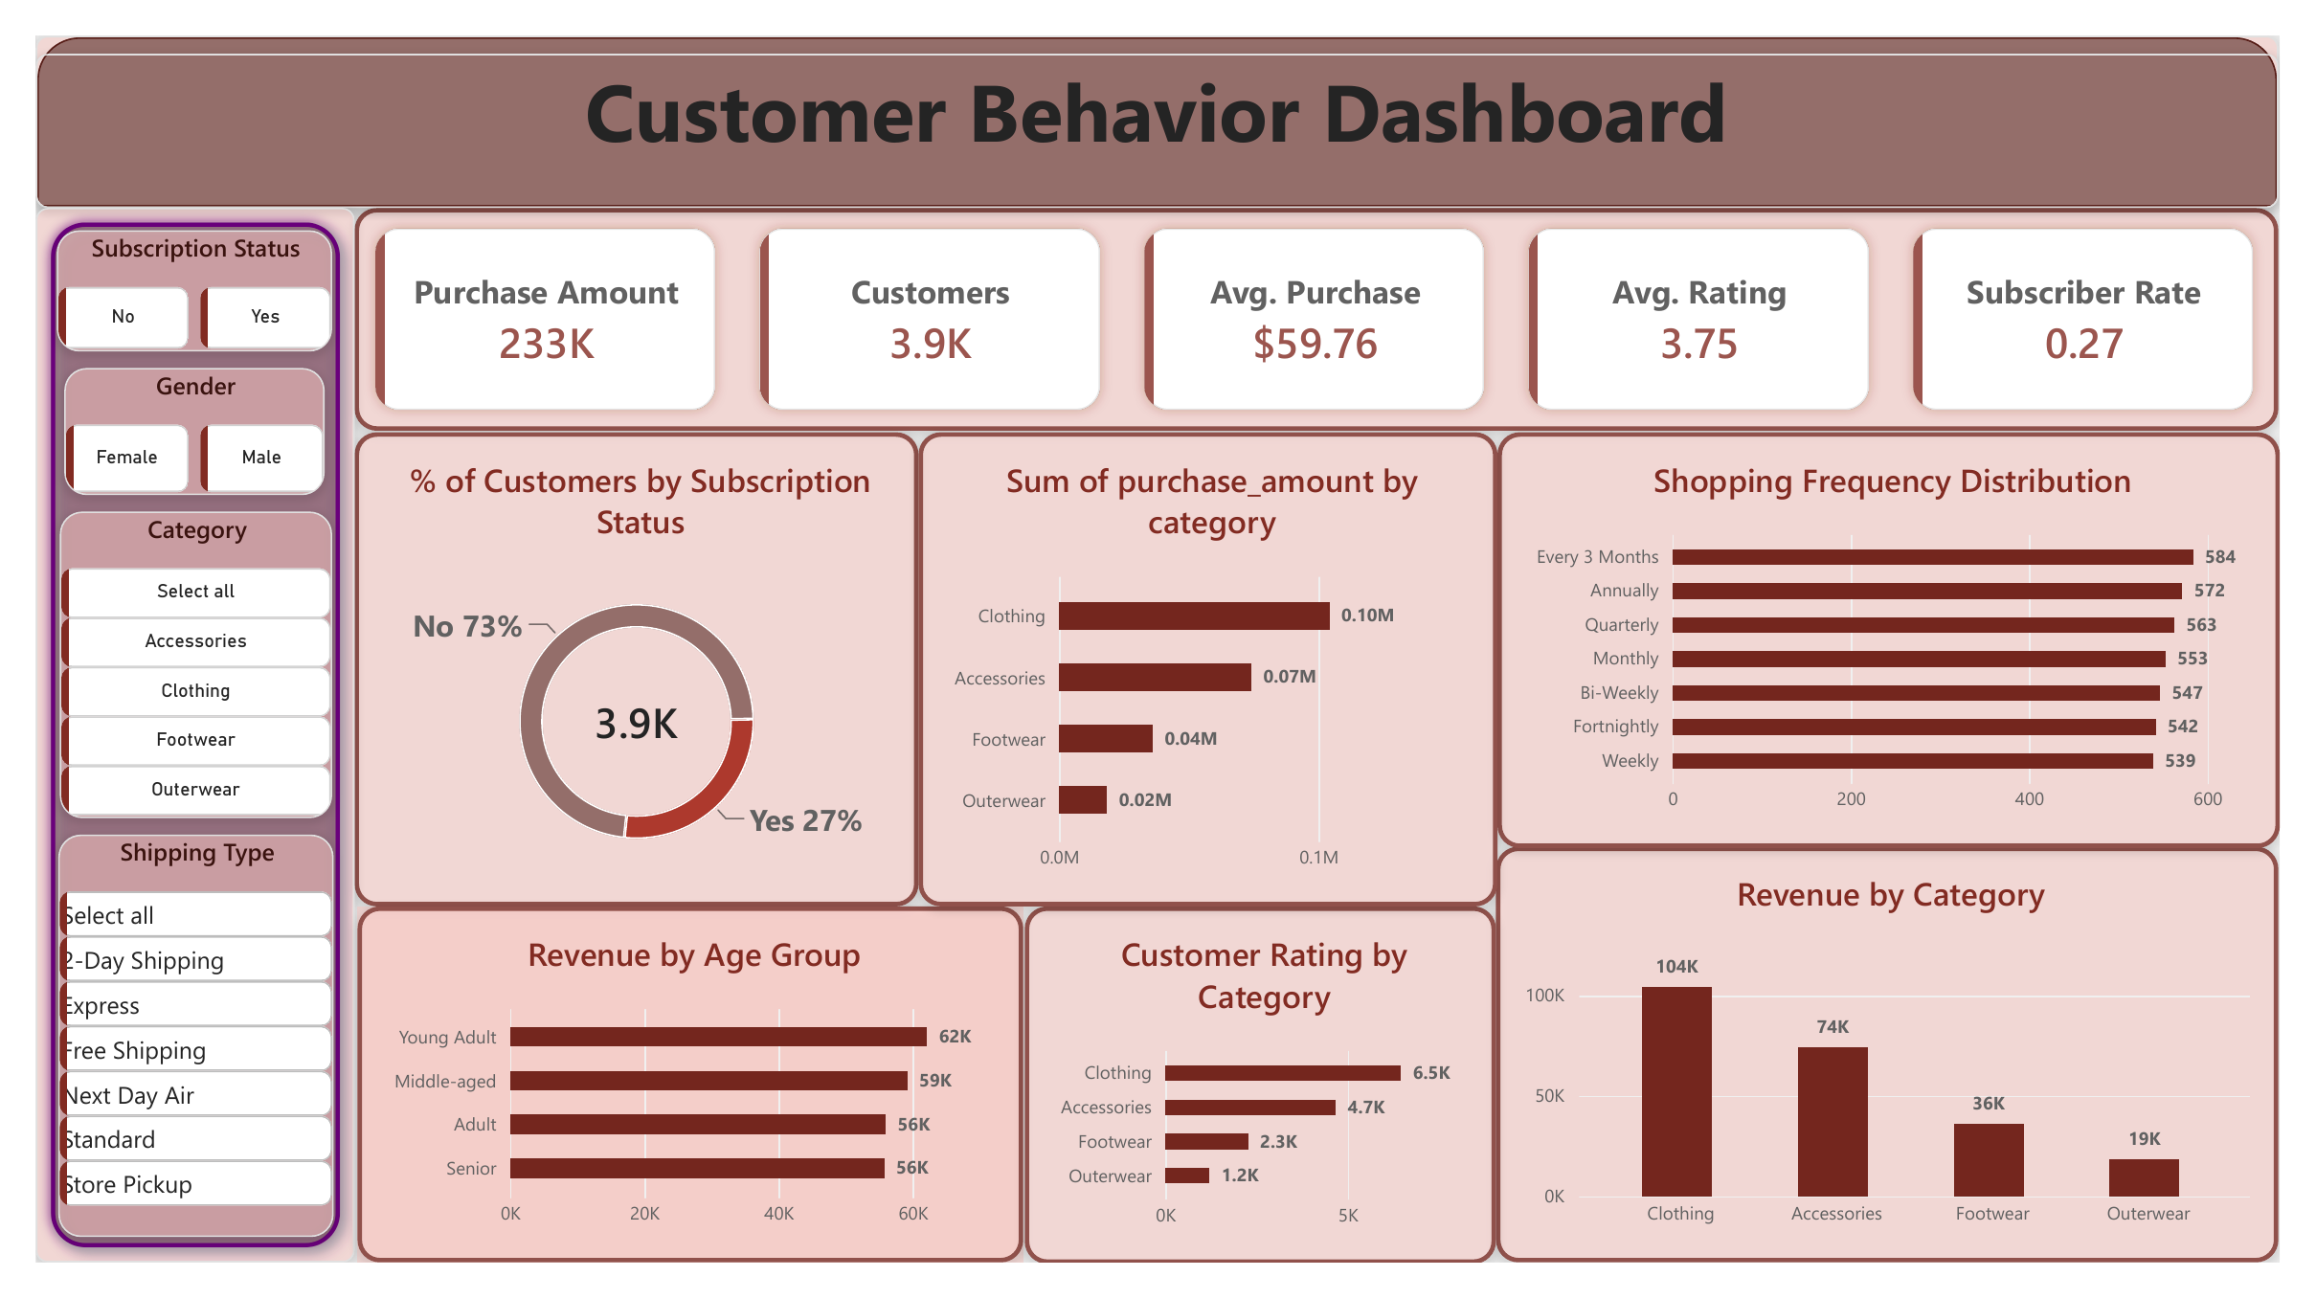

8. Business Recommendations
1. Improve the subscription program
Subscribers do not spend more than other customers, and only 27% of customers subscribe. Add real benefits, such as free shipping or early access to sales, and offer a free trial to repeat buyers who are not subscribed yet.
2. Reduce unnecessary discounts
43% of purchases use a discount, but discounted purchases are not bigger ($59.28 vs. $60.13). Test fewer discounts, starting with Hats, Sneakers and Coats, which are discounted the most.
3. Bring in more new customers
Only 2% of customers are new, and 80% are loyal. Run campaigns and first-purchase offers to attract new buyers.
4. Attract more women customers
Women spend as much as men per purchase but are only 32% of customers. Targeted marketing to women can grow revenue.
5. Boost Outerwear sales
Outerwear is only 8% of revenue and has the lowest average purchase. Bundle it with Clothing items and run seasonal offers.
6. Promote top-rated products and fix weak ones
Promote Gloves, Sandals and Boots, which have the best ratings. Check the quality of Shirts, Jeans and Blouses, which have the lowest ratings.
7. Focus on young customers and top states
Young adults (18–31) bring the most revenue. Montana, Illinois and California are the top states, so focus marketing there.

